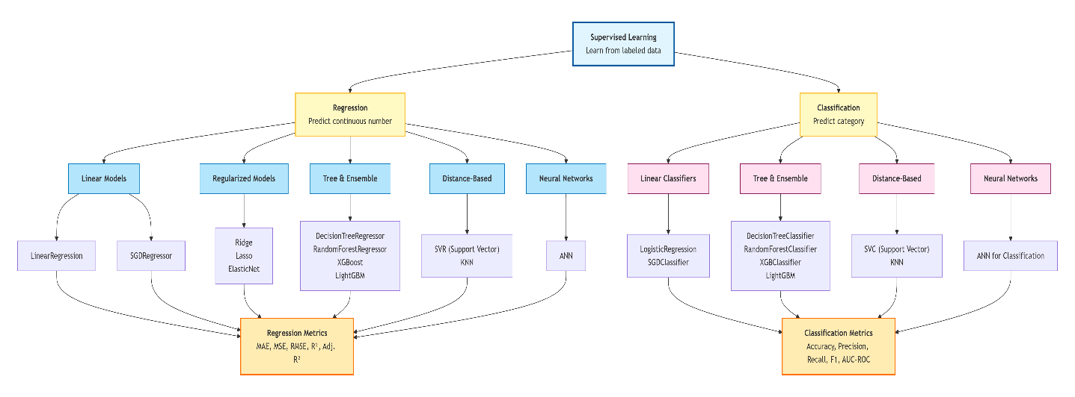
Evaluation Metrics for Regression Models
In regression problems, the target variable is continuous – we predict a number, like house price, temperature, or sales. To know how good our model is, we need to measure the difference between the actual values and the predicted values. Different metrics give us different views of model performance. The main ones are:
- MAE (Mean Absolute Error)
- MSE (Mean Squared Error)
- RMSE (Root Mean Squared Error)
- R² Score (Coefficient of Determination)
- Adjusted R²

- MAE (Mean Absolute Error)
MAE tells you on average, how far off your predictions are from the actual values. It takes the absolute difference between each predicted and actual value, then averages them.
Formula:
$$\text{MAE}=\frac{1}{n}\sum_{i=1}^{n}{∣}y_{i}-{\hat{y}}_{i}∣$$
where:
- $y_{i}$ = actual value
- ${\hat{y}}_{i}$ = predicted value
- $n$ = number of observations
Interpretation:
- Lower MAE means better model.
- MAE = 0 means perfect predictions.
- MAE is in the same unit as the target variable (e.g., dollars for house price).
Why use absolute value?
It prevents positive and negative errors from canceling each other out. For example, errors of −3 and +3 would average to 0 without absolute, but we clearly have errors of size 3.
Example:
Actual | Predicted | Error | Absolute Error
10 | 12 | -2 | 2
20 | 18 | 2 | 2
30 | 29 | 1 | 1
$$\text{MAE}=(2+2+1)/3=1.67$$
So on average, predictions are 1.67 units away from the truth.
Python (sklearn):
python
from sklearn.metrics import mean_absolute_error
y_true = [10, 20, 30]
y_pred = [12, 18, 29]
mae = mean_absolute_error(y_true, y_pred)
print(mae) # 1.666666666666667
- MSE (Mean Squared Error)
MSE squares the errors before averaging. This punishes large errors much more than small ones.
Formula:
$$\text{MSE}=\frac{1}{n}\sum_{i=1}^{n}{(}y_{i}-{\hat{y}}_{i})^{2}$$
Interpretation:
- Lower MSE is better.
- MSE = 0 means perfect predictions.
- The units are squared (e.g., dollars²), which is not as intuitive, but it's very useful for comparing models.
Why squaring?
- It removes negative signs.
- It gives a larger penalty to big mistakes. For example, errors of 1 and 5 become squared errors 1 and 25 – the big error is penalized much more.
Example (same data):
Actual | Predicted | Error | Squared Error
10 | 12 | -2 | 4
20 | 18 | 2 | 4
30 | 29 | 1 | 1
$$\text{MSE}=(4+4+1)/3=3$$
Python (sklearn):
python
from sklearn.metrics import mean_squared_error
mse = mean_squared_error(y_true, y_pred)
print(mse) # 3.0
- RMSE (Root Mean Squared Error)
RMSE takes the square root of MSE. This brings the error back to the original units of the target variable.
Formula:
$$\text{RMSE}=\sqrt{\frac{1}{n}\sum_{i=1}^{n}{(}y_{i}-{\hat{y}}_{i})^{2}}$$
Interpretation:
- Like MAE, lower is better.
- RMSE is in the same unit as the target (dollars), so it's easy to understand.
- It still penalizes large errors more than MAE, because the squaring happens before the square root.
Example (continuing):
$$\text{MSE}=3⇒\text{RMSE}=\sqrt{3}≈1.73$$
Python:
python
import numpy as np
rmse = np.sqrt(mean_squared_error(y_true, y_pred))
print(rmse) # 1.7320508075688772
Why not just use MAE?
RMSE is more sensitive to outliers – if your model makes a few very bad predictions, RMSE will be much higher than MAE. So if you care about avoiding large errors, RMSE is a better metric.
- R² Score (Coefficient of Determination)
R² measures how well the model explains the variance in the target variable. It answers: Compared to just predicting the mean, how much better is my model?
Formula:
$$R^{2}=1-\frac{SS_{res}}{SS_{tot}}$$
where:
- $SS_{res}=∑(y_{i}-{\hat{y}}_{i})^{2}$ (sum of squared residuals, same as MSE × n)
- $SS_{tot}=∑(y_{i}-\overset{ˉ}{y})^{2}$ (total variance in the actual data)
Interpretation:
- R² = 1 : Perfect model. All variance explained.
- R² = 0 : Model is as good as just predicting the mean.
- R² < 0 : Model is worse than the mean baseline (very poor).
Range: Usually between 0 and 1, but can be negative.
Example: If R² = 0.85, the model explains 85% of the variance in house prices. The remaining 15% is due to factors not captured by the model.
Python (sklearn):
python
from sklearn.metrics import r2_score

r2 = r2_score(y_true, y_pred)
print(r2) # 0.955 (for our toy example)
- Adjusted R²
R² has a flaw: when you add more features (even useless ones), R² always increases or stays the same. So you might think your model is improving when it's just overfitting. Adjusted R² fixes this by penalizing the model for including unnecessary features.
Formula:
$$\text{Adjusted }R^{2}=1-\frac{\left(1-R^{2})(n-1\right)}{n-p-1}$$
where:
- $n$ = number of observations
- $p$ = number of features
Interpretation:
- It only increases if the new feature actually improves the model more than expected by chance.
- If you add a useless feature, Adjusted R² will decrease.
How it works:
Situation | R² | Adjusted R²
Useful feature added | Increases | Increases
Useless feature added | Increases | Decreases
Example:
Suppose you have two models:
- Model 1: 2 features, R² = 0.82 → Adjusted R² ≈ 0.81
- Model 2: 10 features, R² = 0.84 → Adjusted R² ≈ 0.79
Even though R² increased, Adjusted R² dropped, telling you the extra 8 features are not useful.

